**24.4)**

**1. Write a hive query find the average age of male and female persons died in the titanic tragedy**

**2. Write a hive query to find the number of people died and survived in each class.**

**DATA SET DESCRIPTION Column 1 : PassengerId Column 2 : Survived (survived=0 & died=1) Column 3 : Pclass Column 4 : Name Column 5 : Sex Column 6 : Age Column 7 : SibSp Column 8 : Parch Column 9 : Ticket Column 10 : Fare Column 11 : Cabin Column 12 : Embarked**

1. **Write a hive query find the average age of male and female persons died in the titanic tragedy**

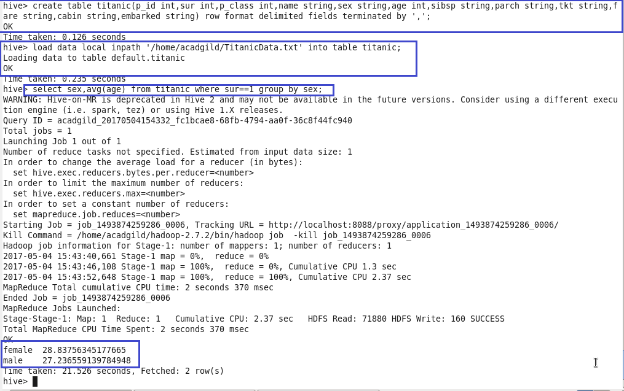



1. **Write a hive query to find the number of people died and survived in each class.**

